AI-Powered Speech Assessment and Adaptive Therapy Platform for Children with Language and Speech Impairments |  |  |  |  |  |  |  |  | Section-I PROJECT APPLICATION SUMMARY
A. DETAILS of PRIME APPLICANT
Project Applicant: |  |  | Nepal Technology Innovation Center (NTIC), Kathmandu University (KU), Dhulikhel, Nepal
Institutional Contact: |  |  | Prof. Dr. Bim Prasad Shrestha |  |  |  |  | Project Leader: |  | Prof. Dr. Bim Prasad Shrestha
Designation: |  |  | Director and Professor |  |  |  |  | Designation: |  | Director and Professor
E-mail: |  |  | shrestha@ku.edu.np |  |  |  |  | E-mail: |  | shrestha@ku.edu.np
Phone: |  |  |  |  |  |  |  | Phone:
C. Project Title: |  |  | AI-Powered Nepali Speech Assessment and Adaptive Therapy Platform for Children with Language and Speech Impairments
D. Duration: | From: |  |  |  | To: |  |  |  |  | Duration in Months: |  |  | 24
E. Project Objectives: | - Establish the Baseline Need and Feasibility for an AI-Powered Speech Therapy Platform in Nepal.  Create the First High-Quality, Annotated Nepali Pediatric Speech Corpus.  - Develop and Validate the Core AI Models and the Integrated Prototype Digital Therapy Platform  Strengthen Kathmandu University's Capacity in Natural Language Processing and Health-Tech Innovation
F. Project Summary | Globally, AI-powered speech assessment and therapy tools are rapidly evolving, with countries like the United States, European nations, and parts of Asia developing platforms that combine automatic speech recognition, adaptive exercises, and real-time feedback to detect and treat speech and language disorders in children. These systems leverage large, high-quality pediatric speech datasets, gamified interventions, and cloud-based monitoring to provide scalable and personalized therapy. However, Nepal currently faces a critical gap in this domain: approximately 5–7% of children aged 5–12 exhibit significant speech impairments, yet fewer than 150 licensed speech-language pathologists are available nationwide, mostly concentrated in urban centers like Kathmandu and Pokhara, leaving children in rural areas with almost no access to early intervention. Furthermore, no high-quality Nepali-language pediatric speech corpus exists, limiting the potential for AI-based detection and therapy tools. To address this gap, this project proposes the development of a Nepali-language AI-powered speech assessment and therapy assistant that integrates computational linguistics, speech processing, and child psychology to provide an end-to-end solution. The system will detect a range of speech impairments—including articulation errors, stuttering, dyslexia-related reading difficulties, and prosody issues—and deliver personalized, gamified exercises that adapt in real time to the child’s performance and engagement, effectively simulating one-on-one therapy sessions. A high-quality Nepali pediatric speech corpus will be created from recordings of over 500 children across different regions and dialects, with annotations by speech-language experts and, in some cases, EEG-based attention monitoring, providing a robust foundation for AI model training. The platform will leverage state-of-the-art AI techniques, including Nepali-specific automatic speech recognition, transformer-based classification models for multi-disorder detection, and an adaptive feedback engine to guide children through exercises. A parent and therapist dashboard will allow monitoring of progress, flag persistent issues, and deliver targeted recommendations, extending intervention beyond clinical settings to homes and schools. This project has both societal and research significance. By providing accessible, culturally grounded, and scientifically validated tools, it has the potential to reach thousands of children who would otherwise lack therapy. From a research perspective, the creation of the Nepali speech corpus and EEG-linked cognitive analysis positions Kathmandu University as a national leader in computational linguistics and speech technology, with high potential for publications, patents, and scalable applications. In essence, this project aims to transform how speech impairments are detected and treated in Nepal, making therapy more accessible, adaptive, and data-driven, and laying the foundation for a long-term research program and professional collaborations that could serve as a model for other low-resource languages and regions.
G. BUDGET SUMMARY (In round figure Lakhs NPR, for funding amount) |  |  |  |  |  |  |  |  |  |  | H. Signature and Seal
Human Resources & Expert |  | Equipment , Software and Technology |  |  |  | Project Logistics and Dissemination |  | Institutional Overhead / Contingency | TOTAL |  | Official Seal of Institution and Signature
4.0 |  | 8.5 |  |  |  | 2.0 |  | 2.0 | 16.5

Kathmandu University
Speech Assistant

SECTION II – PROJECT BACKGROUND AND OBJECTIVES

II-A: Project Background

Speech and language disorders in children include a range of problems affecting articulation (speech sounds), fluency (e.g. stuttering), voice quality, and receptive or expressive language skills. Speech disorders (articulation/phonological, dysarthria, apraxia, voice, fluency) impair the production or clarity of spoken words. Language disorders involve difficulty understanding or formulating language, whether spoken, written or signed [1]. These disorders often co-occur. Untreated, they can impair learning and social development; studies note that persisting communication problems lead to poor academic performance, reduced quality of life and later mental-health issues. In particular, childhood stuttering often ends with therapy, but if left untreated in childhood it “can become a chronic disorder” into adulthood [2].

Global estimates vary by age and criteria, but roughly 5–10% of children have clinically significant speech or language disorders. For example, a landmark review reported a median prevalence of 5.95% across pediatric studies [1]. In Nepal, a large teacher-survey of 2,776 primary-school children (ages ~5–12) found 8.11% had speech-language impairments, comparable to global rates [3]. The Nepal study reported subtype rates roughly as follows:
- Speech (speech-sound) disorders: 4.68% overall (2.95% articulation/phonology, 2.09% stuttering, 3.42% voice problems).
- Language disorders: 8.0% overall (4.97% receptive difficulties, 7.74% expressive difficulties)
These figures align with international findings (e.g. articulation disorders ~8–10% of preschoolers, language impairments ~7–8% of kindergartners). Notably, speech-disorder prevalence declines with age (from ~15–16% at age 3 to ~4% by age 6), so persistent errors in school-age children signal a need for intervention.

Speech/language impairments in childhood have broad impacts. Affected children often struggle in school and social situations, with studies linking communication delays to poorer academic outcomes, reduced social participation, and lower quality of life [2]. For example:
- Poor academic and literacy skills (speech–language deficits predict reading and writing difficulties).
- Emotional and social difficulties (e.g. anxiety, low self-esteem, peer problems).
- Long-term challenges (untreated early speech problems may lead to chronic communication disorders).
Early therapy can reverse or mitigate these effects. Research emphasizes that early intervention is critical: “speech therapy exercises must be individualised, frequent, and intensive” to be effective . In contrast, without timely intervention, problems like stuttering or severe phonological delays often persist and cause ongoing difficulties.
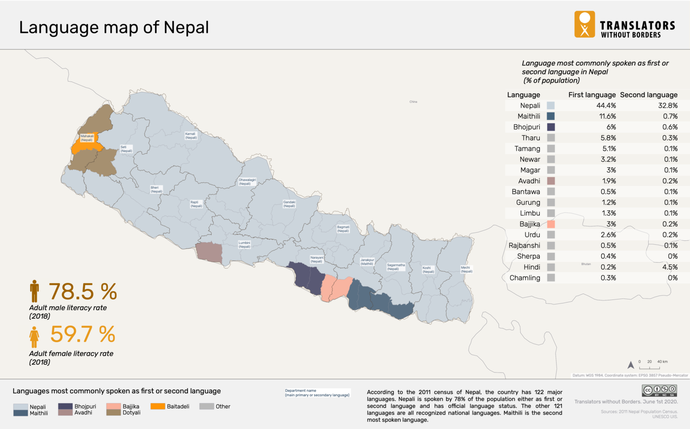

Figure 1: Language Map of Nepal
In Nepal, these issues are compounded by resource gaps. Nepali (an Indo-Aryan language in Devanagari script) is spoken by ~78% of the population (as a first or second language) [4], making it the natural medium for most children. One study of Nepali children’s speech milestones found that all Nepali vowels and diphthongs are typically acquired by age 3, and ~60% of consonants by about age 3.0 [5]. Children become progressively more accurate as they grow, so by primary school (ages 5–12) most native speakers should have mastered basic sounds. Thus persistent pronunciation errors or language delays in this age group likely indicate impairment.Nevertheless, Nepal has few speech therapists and limited services. Most therapy centers and professionals are concentrated in cities, leaving rural children underserved. As noted in a systematic review, “in-person referral to SLPs is not possible due to…limited number of therapists, geographic location, and economic conditions, especially for rural and low-income” families [2]. In practice, NGOs have had to organize speech therapy camps to reach rural kids (e.g. ReSurge International holds free year-round camps in various regions to provide speech therapy and counseling for cleft-palate children). These examples underscore that Nepali-speaking children lack routine access to therapy.
A range of digital speech tools and apps exist internationally (e.g. Speech Blubs, Articulation Station, Otsimo, etc.), and many clinical studies are exploring game-based or teletherapy approaches [2][7]. A recent systematic review of “serious games” for child speech therapy found that most published tools (about 59%) are in English. In other words, most therapy apps assume English or other major languages, not Nepali. Nepal-specific language resources are rare. One example is “Dino Articulation Nepali”, an app by an SLP that teaches Nepali consonant sounds (15 sounds with >100 target words) [6]. Beyond that, few mainstream apps support Nepali phonology or vocabulary. Consequently, Nepali children have very limited access to technology-based therapy content in their own language.

A Nepal-focused speech-therapy project can fill these gaps and boost children’s speaking abilities. By delivering Nepali-language, engaging exercises and feedback, it would make therapy accessible to children outside clinics. Digital delivery means children can practice frequently at home or school, even where therapists are scarce. Reviews emphasize that such digital interventions can complement conventional therapy, extending learning beyond the clinic. In practical terms, an interactive Nepali app could motivate children through game elements and real-time feedback, encouraging them to practice sounds, words and sentences repeatedly. This increased practice is likely to accelerate “speech growth” for example, faster acquisition of new vocabulary and more accurate pronunciation.
Importantly, improving speech early can have lasting effects. Nepal studies note that if speech-language disorders are identified and treated in childhood, many can be remediated before school age. By contrast, delaying intervention risks chronic problems (e.g. 40–60% of preschool stutterers continue into adulthood without therapy) [2]. Thus, a user-friendly Nepali speech app has strong potential to enhance communication outcomes for thousands of Nepalese children. By supporting clear, confident speech and language development in ages ~5–12, the project could significantly improve their educational and social trajectories.

References:
- Rosenbaum, S., Simon, P., Committee on the Evaluation of the Supplemental Security Income (SSI) Disability Program for Children with Speech Disorders and Language Disorders, Board on the Health of Select Populations, Board on Children, Youth, and Families, Institute of Medicine, Division of Behavioral and Social Sciences and Education, & National Academies of Sciences, Engineering, and Medicine (Eds.). (2016). Speech and Language Disorders in Children: Implications for the Social Security Administration's Supplemental Security Income Program. National Academies Press (US). https://doi.org/10.17226/21872
- Saeedi, S., Bouraghi, H., Seifpanahi, M. S., & Ghazisaeedi, M. (2022). Application of Digital Games for Speech Therapy in Children: A Systematic Review of Features and Challenges. Journal of healthcare engineering, 2022, 4814945. https://doi.org/10.1155/2022/4814945
- Thapa, K. B., Okalidou, A., & Anastasiadou, S. (2016). Teachers' screening estimations of speech-language impairments in primary school children in Nepal. International journal of language & communication disorders, 51(3), 310–327. https://doi.org/10.1111/1460-6984.12209
- Translators without Borders. (n.d.). Language data for Nepal. Translators without Borders. https://translatorswithoutborders.org/language-data-for-nepal
- Dawadee, P., & Dawadi, P. (2021). Phonology Acquisition in Nepal: A Preliminary Study. Journal of Child Language Acquisition and Development-JCLAD, 335-342.
- Developer Name. (2016). Dino Articulation - Nepali (Version 1.2) [Mobile app]. Apple App Store. https://apps.apple.com/no/app/dino-articulation-nepali/id1119726535
- Zhou, Z., Deng, C., Yin, D., Yang, Q., & Chen, Z. (2025). Digital Intervention in Children With Developmental Language Disorder: Systematic Review. JMIR mHealth and uHealth, 13, e59992. https://doi.org/10.2196/59992
- Shethia, U., Inamdar, V., & Kulkarni, V. (2025). Evaluating a Digital Speech Therapy App for Stuttering: A Pilot Validation Study. arXiv preprint arXiv:2503.02743.

II-B: Project Objectives and Associated Activities

Project Objective: 1 |  | Establish the Baseline Need and Feasibility for an AI-Powered Speech Therapy Platform in Nepal.
Rationale: |  | A successful technological intervention requires a deep understanding of the problem's scale, the socio-technical landscape, and existing global solutions. This objective focuses on building a data-driven foundation for the project.
WP | Major Associated Activities: |  | Planned inputs: | Anticipated outputs:
1.1 | Collection and systematic review of data on pediatric speech impairment prevalence and therapist availability in Nepal. |  | Literature review, statistics from NHPC & WHO, interviews with healthcare professionals. | A comprehensive report defining the quantifiable need, therapist-to-child ratio, and the urban-rural service gap.
1.2 | Study the landscape of existing global AI-based speech therapy tools and their applicability to low-resource languages. |  | Review of academic papers, analysis of existing therapy applications, expert consultations. | A document outlining best practices, proven therapeutic techniques, and potential technological challenges for the Nepali context.
1.3 | Assess the socio-cultural and technical feasibility of a digital therapy tool for children and parents in Nepal. |  | Stakeholder meetings (parents, teachers, SLPs), surveys on digital literacy, ethical review protocols. | A feasibility and user requirements report, guiding the design of a culturally appropriate and accessible platform.

Project  Objective: 2 |  | Create the First High-Quality, Annotated Nepali Pediatric Speech Corpus.
Rationale: |  | The primary bottleneck for developing Nepali speech technology is the lack of data. This objective is dedicated to creating the foundational asset required for all subsequent AI model development.
WP | Major Associated Activities: |  | Planned inputs: | Anticipated outputs:
2.1 | Design a phonetically and dialectically balanced speech corpus for data collection. |  | Expertise from computational linguists and Nepali SLPs, selection of target words and sentences. | A finalized corpus design document outlining the complete data collection protocol and script.
2.2 | Conduct ethical and systematic field data collection of speech from 500+ children across diverse regions of Nepal. |  | High-fidelity recording equipment, trained research assistants, travel and logistics budget, ethical clearance. | A raw audio dataset of over 500 hours of Nepali children's speech.
2.3 | Transcribe, clean, and annotate the collected speech data with expert validation from SLPs. |  | Human resources for annotation, specialized annotation software, consultation time with SLPs. | A fully transcribed, phoneme-level annotated, and analysis-ready speech corpus, partitioned for model training.

Project  Objective: 3 |  | Develop and Validate the Core AI Models and the Integrated Prototype Digital Therapy Platform.
Rationale: |  | With the corpus created, the next step is to build the intelligence of the system and the user-facing application that will deliver the therapeutic interventions.
WP | Major Associated Activities: |  | Planned inputs: | Anticipated outputs:
3.1 | Train and fine-tune Nepali-specific AI models for Automatic Speech Recognition (ASR) and impairment detection. |  | The annotated speech corpus, AI/ML engineering expertise, high-performance computing resources (GPUs). | A suite of validated AI models capable of accurately transcribing Nepali children's speech and identifying error patterns.
3.2 | Design and develop a child-friendly, gamified mobile/web application with a progress-tracking dashboard. |  | UI/UX design specifications, software development team, gamification concepts, content from SLPs. | A functional beta version of the therapy platform with interactive exercises and a parent/therapist dashboard.
3.3 | Integrate AI models into the platform and conduct a pilot study with children for feedback and performance validation. |  | The developed platform, a cohort of child participants and supervising SLPs, data analysis tools. | A pilot study report with performance metrics, user feedback, and recommendations for refinement.

Project Objective: 4 |  | Strengthen Kathmandu University's Capacity in Natural Language Processing and Health-Tech Innovation
Goal: |  | To build a sustainable foundation of expertise, facilities, and academic output at KU, establishing it as a national hub for speech technology research and development.
WP | Major Associated Activities: |  | Planned inputs: | Anticipated outputs:
4.1 | Publish and disseminate research findings from the project in national and international forums. |  | Research data and results, academic writing time, publication fees. | At least two peer-reviewed publications in relevant journals or conferences, raising the university's research profile.
4.2 | Develop a protocol for the ethical sharing of the anonymized speech corpus to foster a national research community. |  | Legal and ethical consultations, data anonymization tools, a secure data repository. | A publicly available framework and dataset for use by other Nepali researchers, amplifying the project's impact.
4.3 | Supervise and train at least two graduate-level students in speech processing and AI for healthcare. |  | Research stipends, academic supervision, access to project data and computational resources. | A new generation of trained Nepali experts in a high-demand, high-impact technological field.

SECTION III – MARKET PROJECTION / BUSINESS POTENTIAL
3.1. Market Overview & Target Segment
3.1.1 Nepal's Digital Health Market
Nepal's digital health market is projected to reach USD 90.88 million in 2025, with an expected
annual growth rate (CAGR 2025–2029) of 6.63%, resulting in a projected market volume of USD 117.50
million by 2029 (Statista Market Forecast). The broader medical technology market in Nepal is
anticipated to grow at a CAGR of 8.67%, reaching USD 309.88 million by 2030.
The Government of Nepal and WHO jointly developed a National Digital Health Blueprint (workshop
held in April 2025) to serve as a strategic framework for leveraging digital technologies in advancing the
Sustainable Development Goals and Universal Health Coverage in Nepal (WHO Nepal, April 2025).

3.1.2 Nepal's Digital Infrastructure & Reach
Nepal's smartphone penetration has exceeded 139 subscriptions per 100 people (as of 2020, with
continued rapid growth since), creating a strong foundation for mobile-first health and education
applications. Internet access has expanded to 2,481 health institutions, and 431 local-level governments
are actively using internet-based services for public delivery (PMC / Challenges and Opportunities for
Implementing Digital Health Interventions in Nepal, 2022).

3.1.3 Nepal's EdTech Ecosystem & Government Support
Nepal's EdTech sector is growing, supported by specific government programmes. The Startup Enterprise
Loan Programme, formally approved in 2024, provides collateral-free loans ranging from NPR 200,000
to NPR 2 million at a minimal 3% interest rate. In fiscal year 2024–25, the government allocated NPR 1
billion for this programme, resulting in 661 startups securing funding — a nearly 300% increase in
beneficiaries year-on-year. The Digital Nepal Framework and the National E-Library Program further
underscore the government's commitment to digitising educational and health services (Gurkha
Technology, 2025).

3.1.4 Target Population Sizing for Nepal
Nepal's total population is approximately 29.6 million (2025). Approximately 28.5% of the population is
under 14 years of age. Based on UN population data and Nepal's age distribution, the 5–12 age cohort
(the direct target group for vAnI) is estimated at roughly 4.5–5.0 million children.
Applying the documented Nepali speech impairment prevalence rate of 5-7% (from the Thapa et al. 2016
teacher-survey cited in the proposal), of children aged 5–12 in Nepal currently exhibiting clinically
significant speech-language impairments. This represents the immediate addressable need.

3.1.5 The Therapist Gap — A Market Opportunity
Fewer than 150 licensed speech-language pathologists serve the entire country, the majority
concentrated in Kathmandu and Pokhara. This yields a national SLP-to-affected-child ratio of roughly
1:15000, far exceeding the ratios seen in countries with adequate coverage. Rural areas, where
79.42% of the population resides, face compounded financial, geographic, and sociocultural barriers to
accessing care (Kathmandu Post, October 2024).This project directly targets this structural deficit by
functioning as a scalable, AI-driven supplement to clinical services.

3.2. Business Potential & Revenue Pathway Projections

3.2.1 Near-Term (Years 1–3): Pilot & Institutional Adoption

The initial deployment model targets public schools, community health centres, and NGO partner
networks. Potential funding and sustainability sources include:

Government health and education grants aligned with the Digital Nepal Framework and SDG commitments.

International development funding (WHO, UNICEF, World Bank education/health programmes active in Nepal).

Institutional licensing to hospitals and schools on a per-site or per-student basis.

A conservative per-user cost of NPR 500–1,000/year (roughly USD 3.50–7.00), applied to even 5% of
the estimated affected population (~18,000–20,000 users), would generate annual platform revenue
in the range of NPR 9–20 million (USD 63,000–140,000), sufficient to sustain ongoing maintenance
and content development.

3.2 Medium-Term (Years 3–5): Regional & Low-Resource Language Expansion

The creation of the first high-quality Nepali pediatric speech corpus positions this project as a
replicable model for other low-resource languages in South and Southeast Asia. Potential expansion
revenue streams include:

Licensing the platform architecture and AI pipeline to similar projects in Bangladesh, Sri Lanka, or Myanmar.

Research collaboration grants from international bodies (e.g., Wellcome Trust, NIH Fogarthy Centre, Asian Development Bank).

Partnership with telehealth and telemedicine networks already operational in Nepal.

3.3 Long-Term (Years 5+): Digital Health Product Ecosystem

This project’s core technology stack (Nepali ASR, phoneme alignment, adaptive feedback engine)
constitutes a reusable asset base for adjacent digital health products, including reading assessment
tools, pronunciation coaching for second-language learners, and cognitive attention monitoring linked
to EEG data. The global speech therapy software sub-market growing to ~USD 350 million by 2027 and
the AI voice therapy market reaching ~USD 2.31 billion by 2029 indicate strong tailwinds for any
validated, culturally grounded product in this space.

SECTION IV – TECHNICAL CONFIGURATIONS

The technical configuration of the vAnI platform is divided into four core segments: Hardware Infrastructure (for research and data collection), Software Stack (for development and deployment), AI Model Architecture, and the Data Processing Pipeline.
- Hardware Infrastructure
The project requires studio-grade equipment for creating the training corpus and consumer-grade hardware for user deployment.
  - Computational Resources
The project will leverage the Kathmandu University HPC Facility (housed at NTIC). This infrastructure provides the necessary parallel processing power.
This academic supercomputing cluster, equipped with high-throughput GPU nodes, will be rented for specific time windows to execute the computationally intensive training of Transformer models and fine-tuning of ASR systems.

  - Data Collection & Research Lab
To build the first standardized Nepali pediatric speech corpus, the following configurations are specified for the research lab:
    - Audio Capture: Studio-quality microphones (Shure SM7B or Rode NT1) paired with Audio Interfaces (Focusrite / SSL2+) to ensure low-noise recordings essential for training sensitive acoustic models.
    - Portable Acquisition: Zoom H5/H6 recorders for field data collection in rural schools and therapy centers.
    - Cognitive Monitoring (EEG):
      - Muse S (Athena Premium Bundle): For high-sensitivity sleep and focus tracking during therapy pilots.
      - Muse 2 Premium Bundle: For real-time attention and cognitive load measurement during speech exercises.
    - Environment: Portable isolation booths and acoustic panels to standardize recording environments across different locations

  - End-User Hardware
Client Devices: The therapy application is optimized for mid-range Android/iOS smartphones and tablets. The system utilizes the device's internal MEMS microphone for input, with optional support for external TRRS lavalier microphones to improve accuracy in noisy home environments.

- Software & Technology Stack
The application follows a client-server architecture where heavy processing is handled by the backend API.

Component | Technology / Tool | Description
Frontend (App) | Flutter / React | Cross-platform mobile framework to ensure accessibility on both Android and iOS devices with a child-friendly UI.
Backend API | FastAPI / Flask | Python-based REST API to handle audio uploads, user authentication, and model inference requests.
Database | PostgreSQL / Firebase | Stores user profiles, therapy progress logs, and links to audio files. Firebase is used for real-time sync.
Audio Processing | Librosa / PyDub | Used for pre-processing (noise reduction, normalization, silence removal) before model input.

- AI & Model Architecture
The core intelligence of vAni relies on a pipeline of interacting models designed for low-resource languages.
  - Automatic Speech Recognition (ASR):
Base Model: OpenAI’s Whisper (Transformer-based encoder-decoder architecture).
Optimization: The model will undergo Parameter-Efficient Fine-Tuning (PEFT) using LoRA (Low-Rank Adaptation) on the custom "Nepali Pediatric Speech Corpus." This adapts the model to the unique acoustic features of children (higher pitch, formant shifts) without the computational cost of full retraining.

  - Phoneme Alignment:
Montreal Forced Aligner (MFA): Configured with a custom Nepali Grapheme-to-Phoneme (G2P) dictionary. MFA aligns the audio waveform with the text transcript at the millisecond level, enabling the system to pinpoint exactly which phoneme was misarticulated (e.g., detecting a /r/ -> /l/ substitution).

  - Impairment Classifiers:
Stuttering Detection: A ResNet18 or Time-Delay Neural Network (TDNN) architecture analyzes temporal discontinuities in the aligned features to classify disfluency types: repetitions (b-b-ball), prolongations (ssssnake), and blocks.
Dyslexia/Reading Analysis: Sequence models trained to correlate pause duration frequency and specific phonological error rates with established biomarkers for dyslexia.

- Data Processing Workflow
The technical flow of data through the system is configured as follows:
  - Input: Audio is captured via the mobile app (48kHz/16-bit mono) and securely streamed to the backend.
  - Pre-processing: The signal is cleaned (noise suppression) and segmented into variable-length chunks.
  - Feature Extraction:
    - Acoustic Features: MFCCs (Mel-frequency cepstral coefficients), Pitch (F0), and Formants (F1, F2) are extracted to analyze pronunciation quality²³.
    - Visual Alignment: Spectrograms are generated for comparison against "standard" Nepali pronunciation.
  - Inference: The audio passes through the ASR and Classifier models.
  - Feedback Loop: The system computes a "Correctness Score" and "Fluency Index." This data drives the Reinforcement Learning (RL) engine to adjust the difficulty of the next exercise and triggers real-time visual cues (e.g., a tongue placement animation) on the user's screen.

SECTION V: IMPLEMENTATION PLAN AND ACTIVITIES
V-A: Project Implementation Stage and Method

S.N. | Implementation Stage | General Method
1 | Project Coordination and Communication | - A Project Management Committee (PMC) will be formed, including the Project Leader, key team members (AI Lead, Linguistics Lead), expert consultants (Speech-Language Pathologists), and a representative from NTIC, KU. The Project Leader will be responsible for implementing approved activities and will act as the primary link between the project team, KU administration, and NTIC. Regular physical or online meetings will be held to monitor progress against milestones.
2 | Building Research Foundations | - Needs assessment and literature review of global AI therapy tools and Nepal’s speech pathology landscape.  - Corpus design and ethical approval, including a balanced script created with linguists and SLPs, approved by KU’s IRC.  - Systematic data collection from 1,000+ children across diverse regions.  - Corpus annotation with structured transcription, cleaning, and expert labeling to convert raw audio into analysis-ready data.
3 | Translation of Research to Practice | - AI model development using the annotated corpus to train, validate, and fine-tune Nepali ASR and speech-impairment classification models.  - Platform design and development with a child-friendly UI/UX, plus a parent- and therapist-oriented dashboard supported by a full front-end and back-end system.  - System integration and pilot testing by embedding the validated models into a beta app and running a controlled pilot with children and SLPs to assess performance, usability, and early effectiveness.
4 | Training and Dissemination | - Academic capacity building through supervising and training at least two graduate students in computational linguistics and AI for healthcare.  - Knowledge dissemination via high-impact journal publications and conference presentations.  - Community engagement by creating an ethical framework for sharing the anonymized speech corpus with Nepali researchers.  - Stakeholder workshops for SLPs, educators, and healthcare professionals to introduce the platform and collect expert feedback for future growth.
5 | Reporting | - Publication of project progress report on a semi-annual basis.  - Publication of research reports and journal/conference articles.  - Publication of technical and financial reports to meet the project’s requirements.  - Publication of detailed technical reports and associated documents to meet the delivery requirement of the project.

V-B: Quantifiable and Verifiable Outcomes of the Project

Objective | Description | Major Outcomes
Objective: 1 | Establish the baseline need and feasibility for an AI-powered speech therapy platform in Nepal. | • 2 Evidence-Based Study Reports: (1) National therapist gap + pediatric speech impairment landscape, (2) Global review of AI therapy technologies and best practices.  • 1 Stakeholder Workshop with SLPs, educators, and parents.  • 1 Peer-Reviewed Publication outlining project rationale and methodology.  • 2 Public Dissemination Outputs such as a project website, media briefs, or press releases.
Objective: 2 | Create the first high-quality, annotated Nepali pediatric speech corpus. | • 1 National-Scale Annotated Speech Corpus: 500+ hours of validated Nepali child speech data.  • 1 Corpus Design + Data Collection Protocol documenting methodology and standards.  • 1 Ethics & Data Sharing Framework enabling future research access.
Objective: 3 | Develop and validate the core AI models and integrated digital therapy platform. | • 1 Fully Functional Beta Application integrating ASR, impairment detection, and child-friendly UI/UX.  • A Validated AI Model Suite for Nepali ASR and speech impairment classification.  • 1 Pilot Study Report with accuracy metrics, usability findings, and real-world performance outcomes.
Objective: 4 | Strengthen Kathmandu University’s capacity in computational linguistics and health-tech innovation. | • 2 Peer-Reviewed Publications showcasing scientific and technical contributions.  • 1 Final Dissemination Workshop for academic, clinical, and community stakeholders.

SECTION VI – VISIBILITY AND IMPACT
The expected outcomes of the project is to demonstrate technological viability and therapeutic value for speech assessment tools designed for Nepal’s linguistic, cultural, and educational environment. The initiative aims to address a major national gap by enabling early detection and intervention for articulation issues, stuttering, reading difficulties linked to dyslexia, and prosody-related challenges. This will be achieved through automatic speech recognition, phoneme alignment, and adaptive feedback systems.
The project will highlight the potential of a large-scale AI-based therapy platform capable of supporting children across Nepal, including rural communities that lack access to speech-language specialists. Through the creation of a high-quality Nepali pediatric speech corpus, real-time assessment models, and engaging therapy modules, the initiative will drive progress in computational linguistics, educational technologies, and digital health.
Upon full implementation, the platform will be suitable for integration into schools, hospitals, community health centers, and home learning environments. The multidisciplinary nature of the initiative, combining AI, linguistics, psychology, and education, will create avenues for future expansion such as multilingual therapy modules, cognitive attention tracking, and new partnerships with healthcare and telemedicine networks.

On completion of the project the direct benefits will be:

  - Accessible early speech assessment for children above 5 years of age through AI-based screening and practice modules.
  - Creation of the first Nepali pediatric speech corpus to support future AI research and extended speech therapy solutions.
  - Tools for parents, teachers, and clinicians including dashboards, personalized reports, and structured home practice guidance.
  - Reduced reliance on the limited number of speech-language pathologists, allowing rural and underserved areas to receive quality support.
  - Improved educational outcomes by addressing communication barriers early in childhood.
  - Strengthened research capacity at Kathmandu University in speech processing, computational linguistics, and socially impactful AI.
  - Establishment of a long-term innovation pipeline for digital therapeutic solutions in low-resource language contexts.

Relevance to Government of Nepal Priorities:
The initiative aligns with national development goals in the following ways:
- Expanding inclusive digital health and educational services for children with speech and learning difficulties.
- Reducing disparities in healthcare access by bringing therapy tools to underserved populations.
- Promoting innovation and digital transformation in accordance with the ICT Policy and Digital Nepal Framework.
- Supporting human capital development by enhancing communication skills, academic performance, and long-term learning capacity.
- Strengthening national research and innovation ecosystems by fostering collaboration between universities, healthcare institutions, and technology partners.

Relevance to Development Needs and SDGs
The project contributes directly to several priority areas and Sustainable Development Goals:
- Quality Education (SDG 4) by supporting early intervention for speech and reading difficulties.
- Good Health and Well-being (SDG 3) by offering accessible therapeutic tools for children with communication disorders.
- Industry, Innovation, and Infrastructure (SDG 9) by developing advanced digital health and linguistic technologies.
- Reduced Inequalities (SDG 10) by expanding access to high-quality therapy regardless of location.
- Partnerships for the Goals (SDG 17) by enabling collaboration between academic, clinical, and technological experts.

SECTION VII – GENERAL PROJECT MANAGEMENT

VII-A: Institutional Capability for Implementation
Kathmandu University has extensive experience in engineering, AI, and research-based innovation. The University has successfully implemented numerous externally funded projects across diverse technical and interdisciplinary fields. Units such as the Nepal Technology Innovation Center, Research, Development and Innovation Center, the Digital Learning Research Lab, and the Schools of KU have the necessary infrastructure, expertise, administrative frameworks, and manpower to execute this initiative effectively.
KU’s long-standing experience in speech technology, machine learning, data processing, and ethical research provides a strong foundation for developing the project. The Schools of KU and related departments have previously executed complex projects in health technology, computational linguistics, and educational systems, demonstrating readiness for this initiative.

VII-B: Organizational structure and project coordination.
The exact operational and execution modality will be finalized after project selection. However, the following framework is proposed as the baseline approach.
A Project Management Committee (PMC) will be established to guide strategic decisions and oversee the project’s implementation. The PMC will consist of:
- Chair: Director, Nepal Technology Innovation Center (NTIC)
- Member Secretary: Project Co-Investigator
- Members:
• AI/ML Lead
• Linguistics & Corpus Development Lead
• Representative from the National Innovation Center (NTIC), KU
• Finance Officer, Kathmandu University
The PMC will be responsible for planning, supervising, and monitoring all project activities to ensure that the objectives, deliverables, and timelines are met within the approved budget.
The Project Leader will manage day-to-day operations, coordinate all interdisciplinary teams, and serve as the primary liaison between KU, NTIC, and the project members.
For any executive decisions required to maintain project momentum or address unforeseen challenges, the Registrar of Kathmandu University will serve as the final authority on behalf of the PMC.
All financial transactions, procurement, and documentation will strictly follow the financial regulations of Kathmandu University.

VII-C: Risks and Risk Mitigation
Following are the risks and mitigating measures during project implementation:

S.N | Risks Description | Consequences | Mitigation
1 | Organizational Risks (Moderate to High Risk)
1.1 | Ineffective communication among interdisciplinary teams | - Misalignment among AI, linguistic, and clinical components | - Clear communication procedures, regular coordination meetings, defined roles
1.2 | High turnover of technical or clinical personnel | - Delays and loss of expertise | - Commitment-based contracts and thorough documentation
1.3 | Limited availability of qualified speech experts | - Slow progress in corpus annotation | - Early engagement and external collaboration
1.4 | Administrative delays | - Slow initiation of activities | - Advance planning and pre-approval procedures
2 | Financial Risks (Low to Moderate Risk)
2.1 | Under-budgeting due to fluctuating costs | - Increased expenditures | - Reallocate from non-critical areas and schedule cost reviews
2.2 | Inability to use budget within time | - Risk of fund freezing | - Periodic financial assessments and flexible task scheduling
3 | Implementation risk (Moderate to High)
3.1 | Delays in data collection | - Insufficient training data | - Multiple collection sites and contingency planning
3.2 | Ethical challenges in child data management | - Legal and privacy risks | - Strict ethical compliance, consent protocols, anonymization
3.3 | Technical failures in AI models | - Reduced system accuracy or functionality | - Modular development, routine testing, parallel backups
4 | External factors Risks (Moderate to low Risk)
4.1 | Political or educational interruptions | - Disruptions in field visits | - Adaptive scheduling and alternative data collection options
4.2 | Health emergencies | - Suspension of school visits | - Remote or online data collection strategies
VII-D: Transparency and corruption
The project will adhere to KU’s financial, procurement, and auditing guidelines to ensure transparency throughout the entire implementation period. All expenditures will be documented through proper accounting practices and yearly audits. KU maintains strict zero-tolerance policies regarding corruption, requiring full ethical and financial compliance from all team members and partners.

VII-E: Exit Plan
At the conclusion of the initiative:
- All datasets, trained models (where permitted), technical documentation, and system designs will be transferred to designated KU units for long-term maintenance.
- Data collection tools, annotation platforms, and software systems will be handed over to relevant KU research labs for future academic use.
- All research outputs, such as publications, technical reports, and promotional materials, will be archived in KU’s repositories and the official project website.
- Academic components, including postgraduate research, will continue under appropriate long-term university programs.
- If certain activities require extra time, the PMC may request a no-cost extension in accordance with KU procedures.
- Final technical, financial, and audit reports will be submitted to the funding authority within the required timeframe.

VII-F: Financial and Administrative causes
  - The funding will be managed as an external grant under KU’s Finance Division.
  - Procurement processes will follow the Public Procurement Act of Nepal and KU guidelines.
  - Knowledge products will be made open access unless restricted by ethical or privacy considerations.
  - Sensitive speech data will follow strict consent and anonymization protocols.
  - Budget reallocation of up to twenty percent may be approved by the Dean in consultation with the PMC.
  - All financial settlements and administrative closures will be completed within three months of the project’s end.

SECTION VIII: SCHEDULE

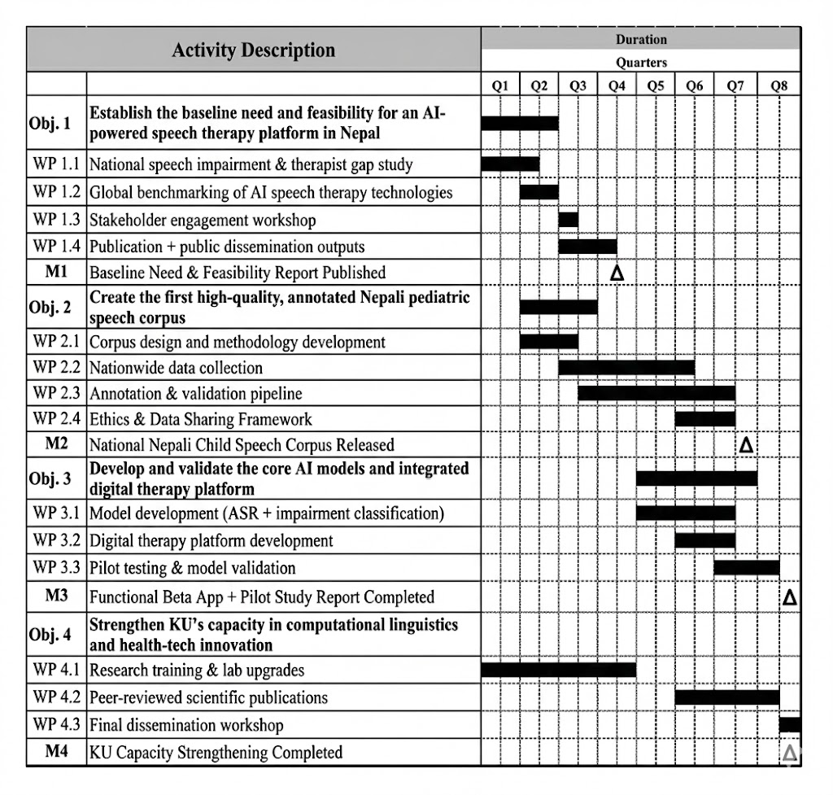

SECTION IX: BUDGET

Detailed Budget Breakdown with EEG Integration (For 2-Year Project Period)

SN | Budget Heading | Unit | # of Units | Unit Rate NPR | Total Budget NPR
A | Human Resource Costs |  | Sub Total (A) |  | 400,000
A.1.1 | Project Leader (Part-time Stipend) | Months | 24 | 5000 | 120000
A.1.2 | Speech-Language Pathologist (Expert Consultation) | Hrs. | 40 | 1500 | 60000
A.1.3 | AI/ML Developer (Expert Consultation) | Hrs. | 40 | 1750 | 70,000
A.1.4 | Research Assistants / Annotators (Temporary) | Day eqv | 100 | 1500 | 150000
B | Equipment, Software, and Technology |  | Sub Total (B) |  | 850,000
B.1 | Portable EEG System | Unit | 1 | 300,000 | 300,000
B.2 | High-Fidelity Audio Recorder | Unit | 1 | 40,000 | 40,000
B.3 | High-Performance Laptop for Data Processing | Unit | 1 | 120,0000 | 120,000
B.4 | Accessories (Mics, SD Cards, EEG Consumables) | LS | 1 | 40,000 | 40,0000
B.5 | Cloud Computing Credits (GPU for AI Training) | LS | 1 | 200,000 | 200,000
B.6 | App Development Services (MVP Contract) | LS | 1 | 150,000 | 150,000
C | Project Logistics and Dissemination |  | Sub Total (C) |  | 200,000
C.1 | Field Data Collection and Logistics (Travel, Accomm.) | LS | 1 | 100,000 | 100,000
C.2 | Participant Incentives and Refreshments | LS | 1 | 50,000 | 50,000
C.3 | Meetings, Workshops and Dissemination | LS | 1 | 50,000 | 50,000
D | Subtotal (A+B+C) |  |  |  | 1,450,000
E | Institutional Overhead and Contingency |  |  |  | 200,000
E.1 | Institutional Overhead (approx. 10% of subtotal) | LS | 1 |  | 145,000
E.2 | Contingency Fund | LS | 1 |  | 55,000
 | TOTAL BUDGET FOR FUNDING (NPR) |  |  |  | 1,650,000
 | TOTAL BUDGET IN LAKHS (NPR) |  |  |  | 16.50

SECTION X: REFERENCES FOR EQUIPMENTS OPTIONS

- EMOTIV FLEX 2 Series (Most feasible and sufficient)
32 Channel wireless EEG head cap system

Model | Channels | Electrode Type | Listed Price (USD) | Key Feature
FLEX 2 Saline | 32 | Saline-based felt sensors | From USD 1,899 | Fast setup; ideal for high-throughput sessions
FLEX 2 Gel | 32 | Gel-based Ag/AgCl | USD 2,299 | Superior signal stability for extended recordings

https://www.emotiv.com/products/flex-saline

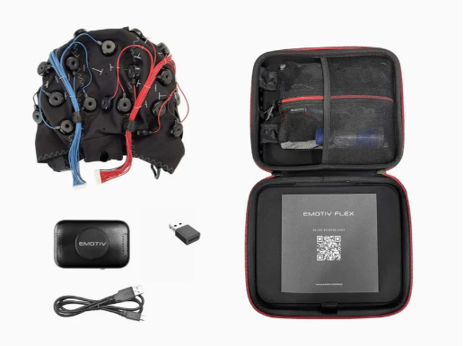

2.Brain Products actiCHamp Plus
System Configuration | Approximate Price (USD) | Notes
actiCHamp Plus 32-ch base module + actiCAP active electrodes + software | ~USD 25,000–30,000 | Full turnkey system; gold-standard signal quality
actiCHamp Plus base module only (without electrodes) | ~USD 15,000–18,000 | Requires separate electrode cap purchase
https://www.brainproducts.com/solutions/actichamp/

